Least Privilege Access with HashiCorp Boundary
  - PROJECT REPORT

Submitted By,
Ponsurabhi V
Computer Science and Engineering (Cyber Security)
Rajalakshmi Engineering College

S.No | CONTENTS | PAGE NO
1. | Acknowledgement | 3
2. | Project Description | 4
3. | Scenarios | 5
4. | Technical Architecture | 6
5. | Pre-requisites | 8
6. | Project Workflow | 9
7. | Project Structure | 11
8. | Epic 1 - Requirement Analysis & Problem Definition | 14
9. | Epic 2 - HashiCorp Boundary Developer Environment | 17
10. | Epic 3 - Secure Resource Configuration | 22
11. | Epic 4 - Secure Session Establishment and Validation | 29
12. | Project Outcomes | 33
13. | Applications | 34
14. | Advantages | 35
15. | Limitations | 36
16. | Future Enhancements | 37
17. | Learning Outcomes | 38
18. | Conclusion | 39
19. | References | 40
20. | Appendix | 41

INDEX

Acknowledgement
I would like to express my sincere gratitude to SmartBridge, SkillWallet, and NASSCOM for providing me with the opportunity to participate in the NASSCOM VIP Cyber Security Associates (ZTCA) internship program.
I am deeply grateful to our Instructor, Ms. Swetha, for her guidance, encouragement, and continuous support throughout the internship. I also extend my sincere appreciation to our mentors, Mr. Hemaditya , Ms. Pranitha Siri, and Ms. Kavya, for their invaluable technical guidance, constructive feedback, and constant encouragement during the successful implementation of the project, "Least Privilege Access With Hashicorp Boundary".
I would also like to thank the SmartBridge and SkillWallet teams for designing a well-structured internship program that provided practical exposure to enterprise cybersecurity technologies and Privileged Access Management (PAM), Zero Trust Architecture (ZTA), and Secure Remote Access Management concepts.
Finally, I express my heartfelt gratitude to my institution, faculty members, and everyone who supported and encouraged me throughout this internship. The knowledge, practical experience, and technical skills gained through this program have significantly strengthened my understanding of privileged access management and will serve as a valuable foundation for my future endeavors in cybersecurity.
Sincerely,
Ponsurabhi V

Project Description:
Least Privilege Access with HashiCorp Boundary is a security-focused infrastructure project that implements identity-based privileged access management for internal servers without exposing administrative services to the public network. The solution follows the principles of Zero Trust Architecture by ensuring that every connection request is authenticated, authorized, and established only for the duration of an active user session.
The project utilizes HashiCorp Boundary as the centralized secure access broker to manage remote access to internal SSH services. Instead of exposing SSH ports or distributing permanent SSH keys, Boundary authenticates users, authorizes access based on configured resources, and establishes temporary secure sessions to protected hosts. The demonstration environment is deployed using Docker containers running an SSH server while Boundary operates in Developer Mode for simplified testing and configuration.
Traditional remote administration methods expose SSH services directly to the network, making them attractive targets for unauthorized access, brute-force attacks, credential theft, and persistent key misuse. Administrators often rely on long-lived SSH keys and publicly accessible SSH ports, increasing the organization's attack surface. HashiCorp Boundary eliminates these security risks by acting as an identity-aware access gateway that never exposes internal resources directly to external users.
The project demonstrates how organizations can implement secure privileged access without VPNs or permanent credentials by enforcing the Principle of Least Privilege. Every connection is created only after successful authentication and authorization, and the session automatically terminates once the required administrative task is completed.

Scenarios
Scenario 1: Secure Administrative Access to Internal Servers
System administrators require secure access to Linux servers for maintenance and troubleshooting. Instead of exposing SSH services directly over the network, HashiCorp Boundary authenticates the administrator, verifies authorization, and creates a temporary SSH session that allows secure access without exposing the server publicly.

Scenario 2: Least Privilege Access Enforcement
Organizations require administrators to access only specific infrastructure resources required for their assigned responsibilities. HashiCorp Boundary allows administrators to access only authorized hosts and services by defining Host Catalogs, Host Sets, and Targets, thereby preventing unnecessary access to unrelated systems.

Scenario 3: Elimination of Permanent SSH Credentials
Traditional environments depend on permanent SSH keys that remain valid indefinitely unless manually revoked. HashiCorp Boundary removes this dependency by establishing temporary authenticated sessions, eliminating the need for long-lived credentials while significantly reducing the risk of credential compromise and unauthorized access.

Technical Architecture

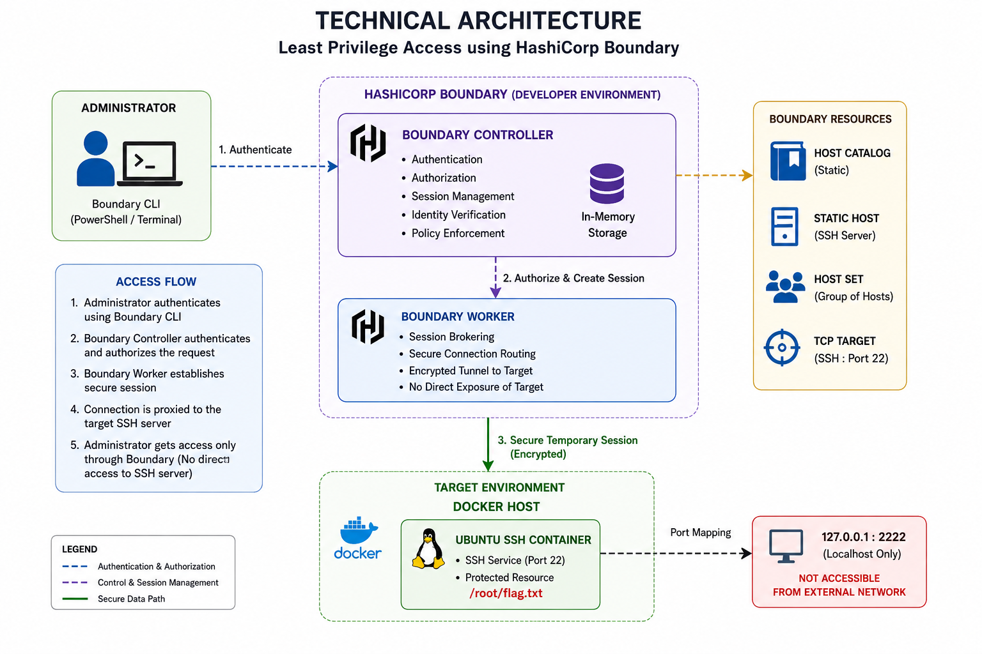
Description:
The Least Privilege Access with HashiCorp Boundary project follows a layered architecture designed to provide secure, identity-aware remote access to protected infrastructure. Rather than allowing users to establish direct SSH connections, all access requests are routed through HashiCorp Boundary, where authentication, authorization, and session management are centrally enforced.

Access Management Layer (HashiCorp Boundary)
HashiCorp Boundary operates as the centralized access management platform responsible for authenticating users, authorizing access requests, managing Host Catalogs, Host Sets, Targets, and establishing secure temporary SSH sessions. Boundary Developer Mode provides the Controller, Worker, and storage services required for demonstration purposes.

Authentication Layer
Users authenticate using Boundary's built-in password authentication method. After successful authentication, Boundary issues a temporary session that grants access only to authorized resources without exposing permanent SSH credentials.

Resource Layer (Docker SSH Server)
A Docker container hosting an Ubuntu SSH server serves as the protected infrastructure resource. The SSH service is mapped only to the localhost interface (127.0.0.1:2222), ensuring that it remains inaccessible from external networks and can only be reached through Boundary.

Session Management Layer
Boundary establishes temporary SSH tunnels between authenticated users and protected resources. Once the user completes the administrative task and disconnects, the session automatically terminates, ensuring that no persistent privileged connections remain active.

Network Layer
The Docker container operates within an isolated environment while exposing the SSH service exclusively through the localhost interface. This configuration prevents external systems from directly accessing the SSH server and enforces all administrative access through Boundary's secure authorization workflow.

Pre-requisites
- HashiCorp Boundary CLI (Developer Mode)
- Docker Desktop (Latest Stable Version)
- Docker Engine 24.x or later
- Ubuntu SSH Docker Image (rastasheep/ubuntu-sshd:18.04)
- Windows PowerShell
- Windows Operating System
- Internet connectivity for downloading Docker images
- Basic understanding of SSH protocol and secure remote access
- Knowledge of Docker container management
- Familiarity with TCP/IP networking and port forwarding
- Understanding of Zero Trust Architecture principles
- Knowledge of Identity-Based Access Management (IBAM)
- Basic understanding of Least Privilege security principles

Project Workflow
Story 1: Requirement Analysis and Problem Definition
1.1 Analyze the security challenges associated with traditional SSH-based remote administration.
1.2 Identify the risks of publicly exposed SSH ports and long-lived SSH credentials.
1.3 Define the functional and non-functional requirements for implementing Least Privilege Access using HashiCorp Boundary.
1.4 Design a secure privileged access solution based on Zero Trust Architecture and the Principle of Least Privilege.

Story 2: HashiCorp Boundary Environment Setup
2.1 Initialize the HashiCorp Boundary Developer Environment.
2.2 Deploy the Ubuntu SSH Server using Docker.
2.3 Create the protected demonstration resource (/root/flag.txt) within the Docker-based SSH Server.
2.4 Authenticate to the HashiCorp Boundary Controller using the Boundary CLI.
2.5 Identify the Project Scope required for configuring infrastructure resources.

Story 3: Secure Infrastructure Resource Configuration
3.1 Create the Static Host Catalog within the identified Project Scope.
3.2 Register the Docker-based Ubuntu SSH Server as a Static Host.
3.3 Create a Static Host Set for organizing protected infrastructure resources.
3.4 Associate the registered Static Host with the configured Host Set.
3.5 Create a TCP Target to securely broker SSH communication.
3.6 Associate the Host Set as the Host Source for the configured TCP Target.

Story 4: Secure Session Establishment and Validation
4.1 Establish a secure SSH session through HashiCorp Boundary.
4.2 Authenticate and authorize administrator access to the protected Ubuntu SSH Server.
4.3 Retrieve the protected demonstration resource (/root/flag.txt) from the secure SSH session.
4.4 Verify that the SSH service is bound exclusively to the localhost interface (127.0.0.1:2222).
4.5 Validate the successful implementation of Least Privilege Access using HashiCorp Boundary.

Project Structure
The project consists of multiple integrated components that collectively provide secure privileged access to protected infrastructure while ensuring that administrative services remain hidden from external networks.
Least Privilege Access using HashiCorp Boundary
├── Boundary Developer Mode
│ ├── Controller
│ ├── Worker
│ └── Authentication Method
│
├── Docker Container
│ └── Ubuntu SSH Server
│
├── Project Scope
│ └── Default Project
│
├── Host Catalog
│ └── p4-catalog
│
├── Static Host
│ └── p4-host
│
├── Host Set
│ └── p4-hostset
│
├── TCP Target
│ └── p4-target
│
├── Secure Session
│ ├── SSH Connection
│ ├── Temporary Access
│ └── Session Authorization
│
├── Protected Resource
│ └── /root/flag.txt
│
└── Security Validation
├── Localhost Verification
├── Port 2222 Validation
└── Least Privilege Verification

HashiCorp Boundary Developer Environment
The Boundary Developer Environment serves as the centralized access management platform responsible for authenticating users, authorizing access requests, managing protected resources, and establishing temporary secure sessions. The Developer Mode automatically provisions the Boundary Controller, Worker, and in-memory storage required for demonstration purposes.

Docker-based SSH Server
A lightweight Ubuntu SSH server is deployed within a Docker container to simulate an internal production server. The SSH service is configured to listen on port 22 inside the container while being mapped exclusively to the localhost interface (127.0.0.1:2222) on the host machine, thereby preventing direct external access.

Boundary CLI
The Boundary Command Line Interface (CLI) enables administrators to authenticate with the Boundary Controller and perform resource management operations. Using the CLI, administrators create Host Catalogs, Hosts, Host Sets, Targets, and securely initiate remote SSH sessions without exposing privileged credentials.

Host Catalog
The Host Catalog functions as the logical repository for infrastructure resources managed by Boundary. It organizes protected hosts within a project scope, enabling centralized administration and simplified resource management.

Static Host
The Static Host represents the protected SSH server deployed inside the Docker container. It contains the network address of the target system and acts as the endpoint that authorized users access through Boundary.

Host Set
The Host Set logically groups one or more hosts within the Host Catalog. This grouping mechanism enables administrators to efficiently associate multiple hosts with Boundary Targets while simplifying access policy management.

TCP Target
The TCP Target defines the secure connection endpoint used by authenticated users. It specifies the communication protocol, destination port, and associated Host Sets, allowing Boundary to establish temporary SSH sessions only after successful authentication and authorization.

Protected Resource
The protected resource is the internal Ubuntu SSH server containing the demonstration file (/root/flag.txt). Access to this resource is granted exclusively through Boundary's secure access workflow, ensuring that direct SSH connectivity remains unavailable to unauthorized users.

Security Validation
The final component of the project focuses on validating the implemented security controls. Successful retrieval of the protected file through Boundary, combined with verification that the SSH service remains bound only to the localhost interface, demonstrates the successful implementation of identity-based, least-privilege remote access without exposing administrative services to the public network.

Epic 1 – Requirement Analysis & Problem Definition
In this Epic, the project foundation is established by identifying the security limitations of traditional SSH-based remote administration, proposing a secure identity-aware access solution using HashiCorp Boundary, and defining both the functional and non-functional requirements required to implement Least Privilege Access within a Zero Trust environment.

Story 1.1: Problem Definition
The primary problem addressed by this project is the security risk associated with traditional SSH-based administrative access. Organizations frequently expose SSH services directly to internal or external networks by opening SSH port 22 and distributing long-lived SSH credentials to administrators. Although this approach simplifies remote administration, it significantly increases the attack surface and exposes privileged infrastructure to brute-force attacks, credential theft, unauthorized access, and lateral movement following an initial compromise.
Traditional administrative models rely heavily on implicit trust once authentication is completed. Administrators are typically granted unrestricted access using permanent SSH keys that often remain active for extended periods without centralized management or automated revocation. As enterprise infrastructures continue to migrate toward cloud-native and distributed environments, this model no longer satisfies modern Zero Trust security principles.

Key challenges in traditional privileged access include:
- Publicly exposed SSH services that can be discovered through network scanning.
- Long-lived SSH keys that remain valid until manually revoked.
- Lack of centralized authentication and authorization before privileged access.
- Direct administrator-to-server connectivity without secure session brokering.
- Limited visibility into privileged session establishment and infrastructure access.
- Increased attack surface resulting from permanently accessible administrative services.

Story 1.2: Proposed Solution
This project implements a Least Privilege Access Management solution using HashiCorp Boundary as the centralized secure access broker. Instead of allowing administrators to connect directly to protected infrastructure, Boundary authenticates every user, verifies authorization, and establishes temporary encrypted SSH sessions only after successful identity validation.
The protected Ubuntu SSH Server is deployed inside a Docker container and remains isolated from external networks by binding the SSH service exclusively to the localhost interface. Infrastructure resources are organized using Boundary Host Catalogs, Static Hosts, Host Sets, and TCP Targets, enabling secure identity-aware administration while eliminating permanently exposed SSH services and long-lived administrative credentials.
The solution demonstrates the Zero Trust principle of "Never Trust, Always Verify" by ensuring that every privileged connection is individually authenticated, authorized, and securely brokered before access to protected infrastructure is granted.

Story 1.3: Functional Requirements
- Boundary Developer Mode shall provide centralized Controller and Worker services for privileged access management.
- The system shall authenticate administrators using the Boundary Password Authentication Method.
- The solution shall deploy a protected Ubuntu SSH Server inside a Docker container.
- The SSH service shall remain accessible only through the localhost interface (127.0.0.1:2222).
- Administrators shall create Host Catalogs, Static Hosts, Host Sets, and TCP Targets using the Boundary CLI.
- Boundary shall establish temporary encrypted SSH sessions to authorized infrastructure resources.
- Protected resources such as /root/flag.txt shall be accessible only after successful authentication and authorization.
- All privileged access shall be brokered through HashiCorp Boundary rather than direct SSH connectivity.

Story 1.4: Non-Functional Requirements
Security: Administrative access shall follow Zero Trust principles by requiring authentication and authorization before every privileged session.
Least Privilege: Users shall receive only the minimum level of access required to perform administrative tasks.
Infrastructure Isolation: Protected SSH services shall remain inaccessible from external networks by binding only to the localhost interface.
Portability: The entire implementation shall be deployable using Docker containers and HashiCorp Boundary Developer Mode.
Maintainability: Infrastructure resources shall be centrally managed through Boundary using logical resource organization.
Scalability: Additional infrastructure resources shall be integrated through Host Catalogs and Host Sets without significant architectural changes.

Story 1.5: Technology Stack
The implementation of Least Privilege Access using HashiCorp Boundary utilizes a combination of modern security tools, containerization technologies, and command-line utilities to establish a secure, identity-aware remote access solution. The selected technology stack enables the implementation of the Principle of Least Privilege while supporting Zero Trust Architecture through centralized privileged access management.
Technology Stack
|
Component | Technology Used
Access Management | HashiCorp Boundary
Containerization | Docker Desktop
Protected Server | Ubuntu SSH Server (`rastasheep/ubuntu-sshd:18.04`)
Authentication | Boundary Password Authentication
Command Line Interface | Boundary CLI
Terminal | Windows PowerShell
Secure Communication | SSH
Host Operating System | Windows 11

Epic 2 – HashiCorp Boundary Developer Environment
This Epic covers the deployment and configuration of HashiCorp Boundary as the centralized privileged access management platform for the Least Privilege Access system. HashiCorp Boundary handles administrator authentication, resource management, secure session brokering, and temporary SSH access to protected infrastructure. The Boundary Developer Server is executed locally and automatically provisions the Controller, Worker, Authentication Method, administrative credentials, and project scope required for configuring secure access resources.

Story 2.1: Boundary Developer Server Initialization
The HashiCorp Boundary Developer Server provides a lightweight demonstration environment for configuring secure remote access. Unlike a production deployment, Developer Mode automatically provisions all core Boundary components, including the Controller, Worker, Authentication Method, Organization Scope, Project Scope, and default administrative credentials.
The Boundary Controller is responsible for authentication, authorization, resource management, and session lifecycle management, while the Worker securely brokers connections between authenticated administrators and protected infrastructure resources.
Upon successful initialization, Boundary displays the generated Authentication Method ID, administrative username, password, organization scope, and project scope. These automatically generated resources are utilized throughout the remaining implementation to configure secure access to the protected SSH server.
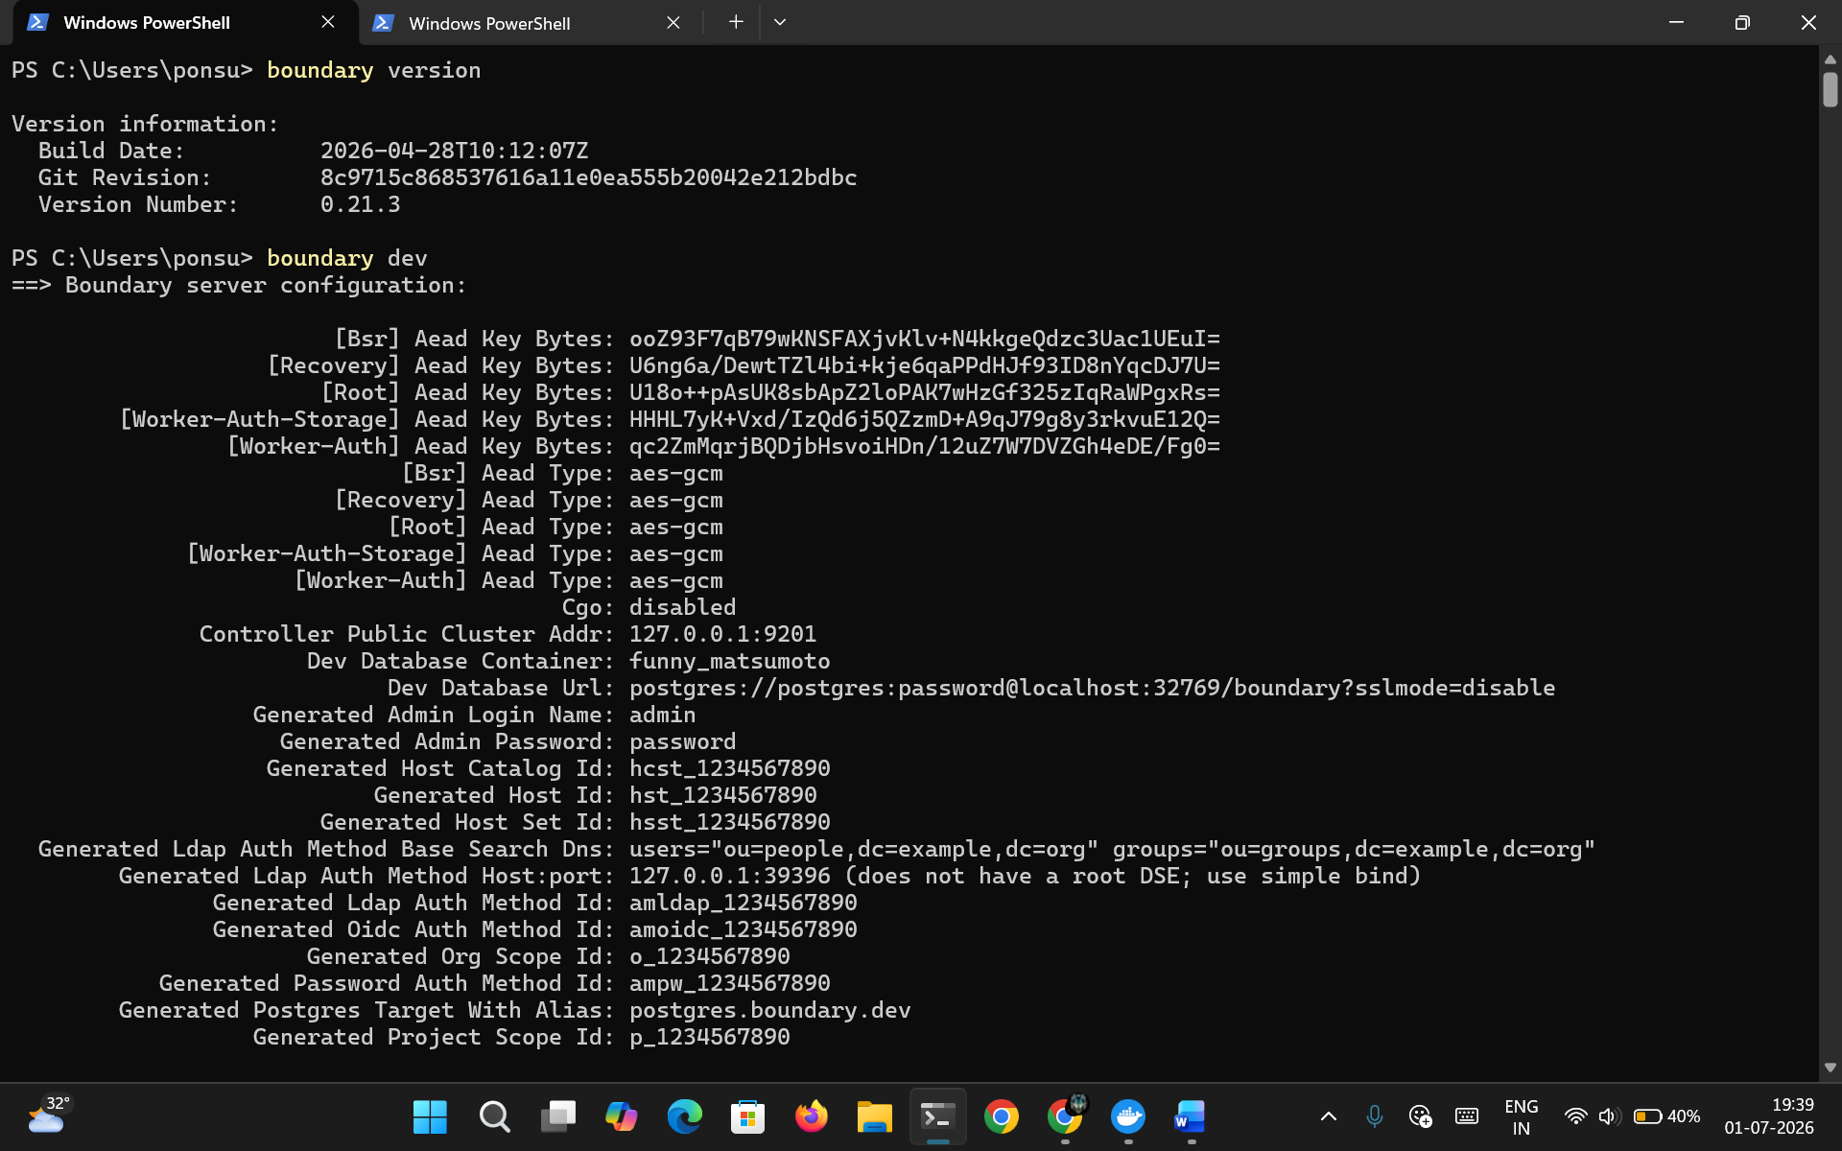
Figure 2.1: HashiCorp Boundary Developer Server Initialization
This figure illustrates the successful initialization of the HashiCorp Boundary Developer Server. The console output displays the generated administrative credentials, Authentication Method ID, Organization Scope, and Project Scope required for configuring secure access resources.

Story 2.2: Deployment of Protected SSH Server
To simulate an internal enterprise server, an Ubuntu SSH Server is deployed using Docker Desktop. The Docker container hosts the SSH service on port 22, while the host machine maps the service exclusively to 127.0.0.1:2222. Restricting the service to the localhost interface prevents direct external access and ensures that all privileged administrative sessions are established through HashiCorp Boundary.
A protected demonstration file (/root/flag.txt) is subsequently created within the Docker container. This file represents confidential infrastructure data that can only be accessed after successful authentication and authorization through Boundary.
The Docker container provides an isolated execution environment that accurately represents an enterprise infrastructure resource while maintaining a simplified development environment suitable for demonstrating Least Privilege Access.
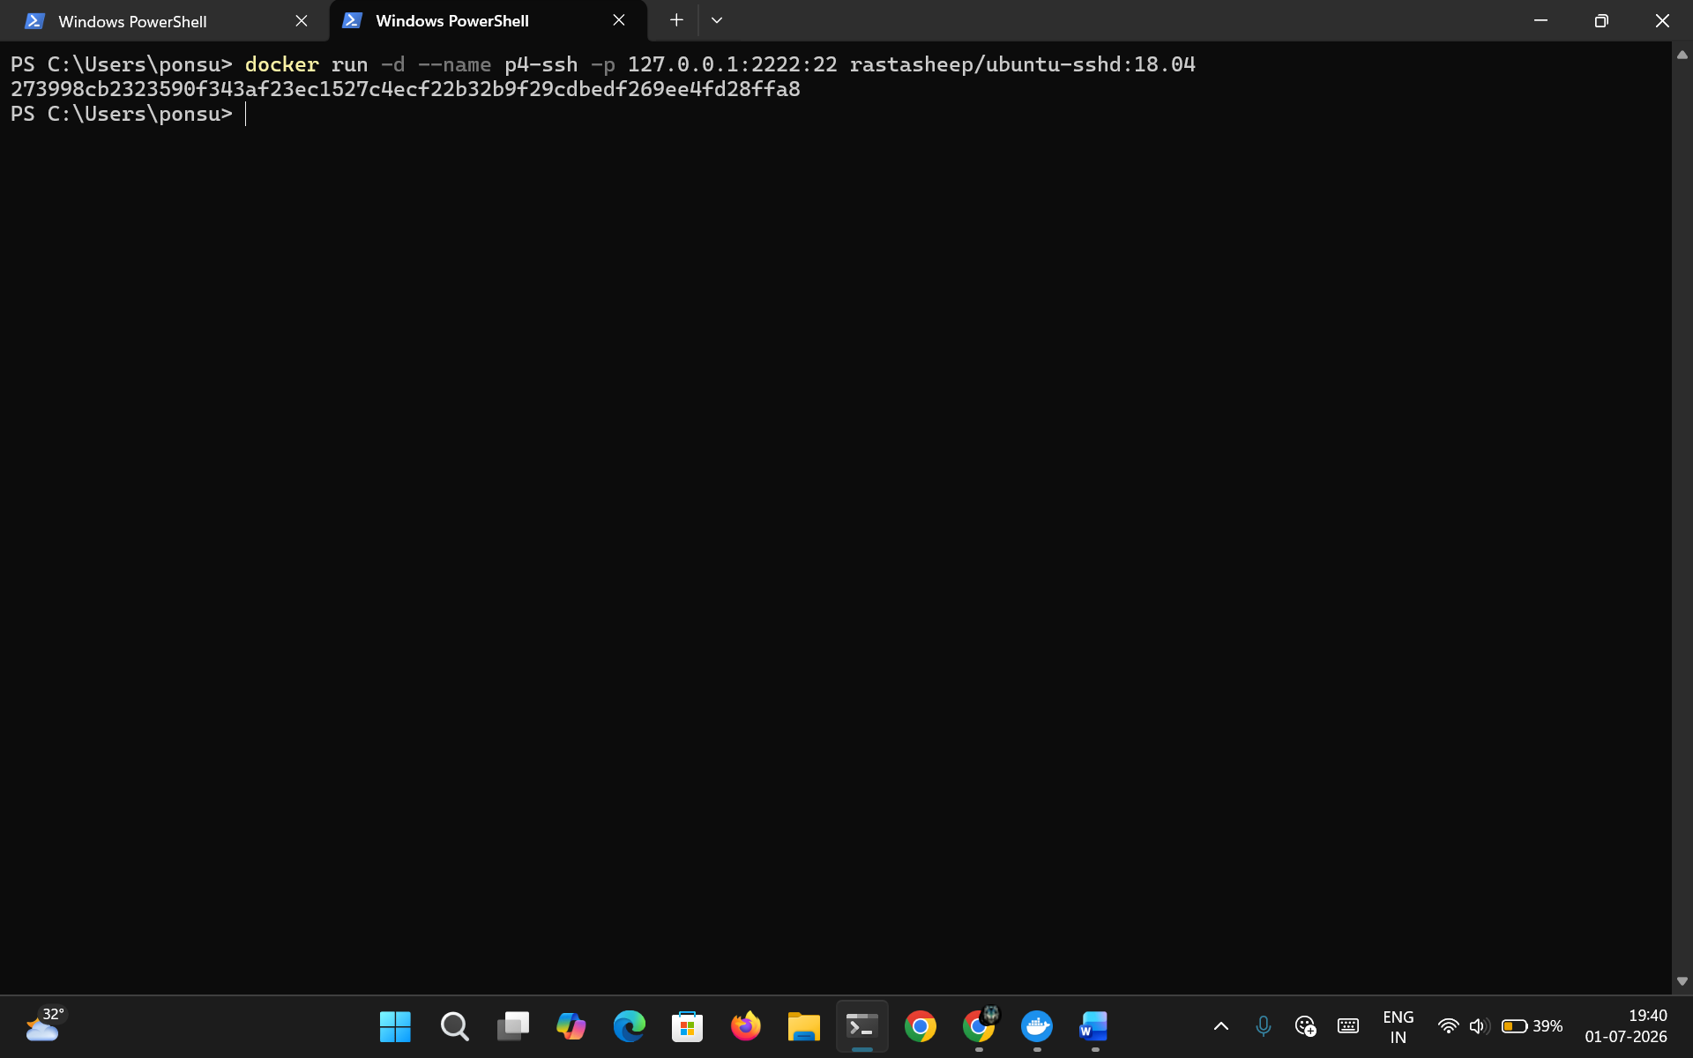
Figure 2.2: Deployment of Ubuntu SSH Server using Docker
This figure illustrates the successful deployment of the Ubuntu SSH Server inside a Docker container. The SSH service is configured to listen internally on port 22 while remaining accessible only through localhost port 2222.
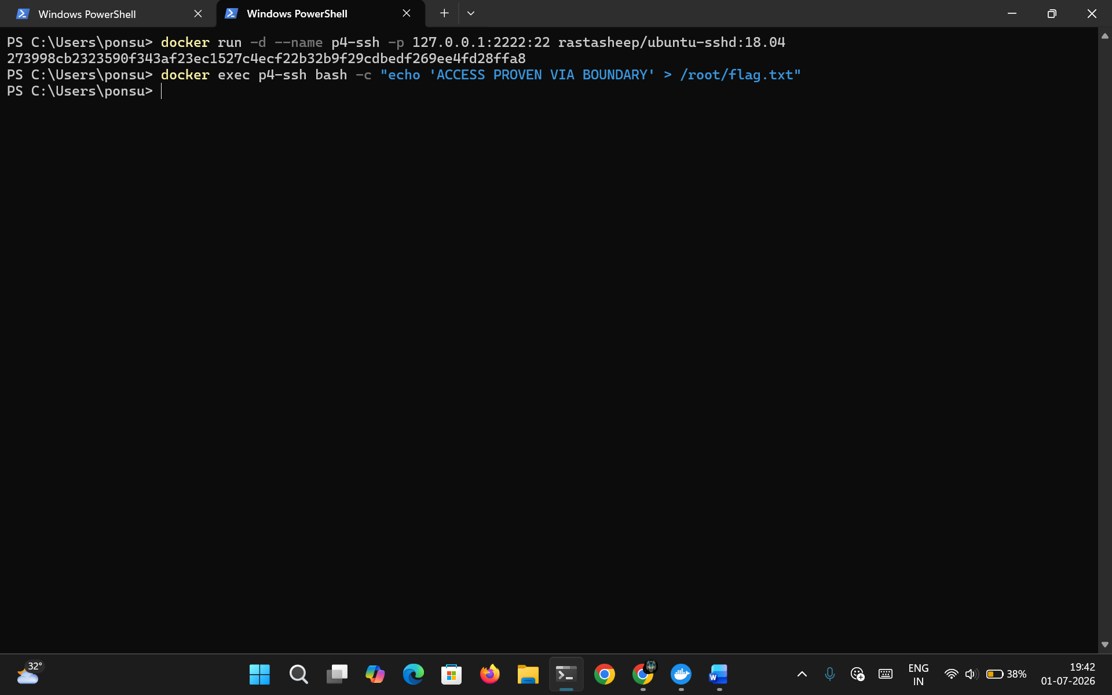
Figure 2.3: Creation of Protected Demonstration Flag
This figure presents the creation of the protected demonstration file (/root/flag.txt) inside the Docker-based Ubuntu SSH Server. The file serves as the protected resource that will later be accessed through HashiCorp Boundary.

Story 2.3: Boundary CLI Authentication
After successfully deploying the development environment, the administrator authenticates with the HashiCorp Boundary Controller using the Boundary Command Line Interface (CLI). Authentication is performed using the generated Password Authentication Method together with the default administrative credentials created during Boundary initialization.
Successful authentication establishes a secure management session, allowing the administrator to create and manage protected infrastructure resources through Boundary's centralized access management framework.
Following authentication, the available project scope is identified and selected as the administrative workspace for configuring Host Catalogs, Static Hosts, Host Sets, and TCP Targets.
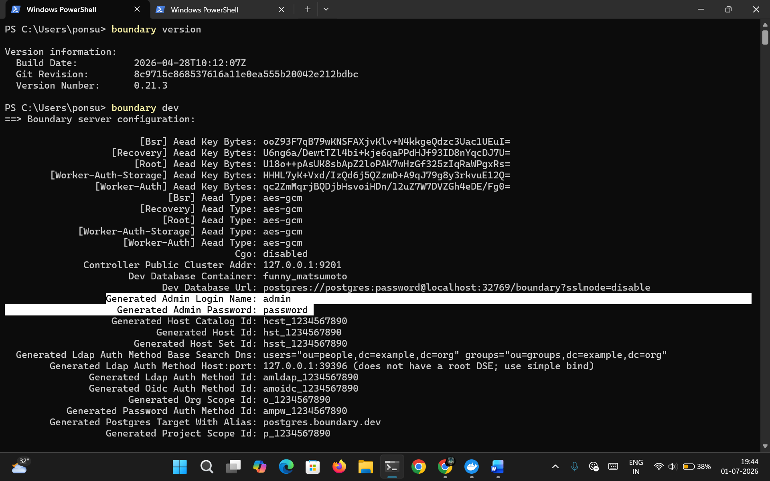
Figure 2.4: Identification of generated credentials

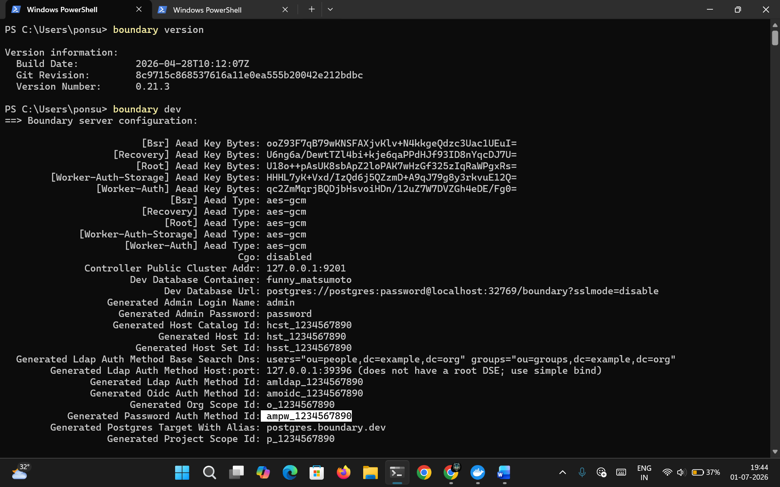
Figure 2.5: Identification of Auth-Method Id
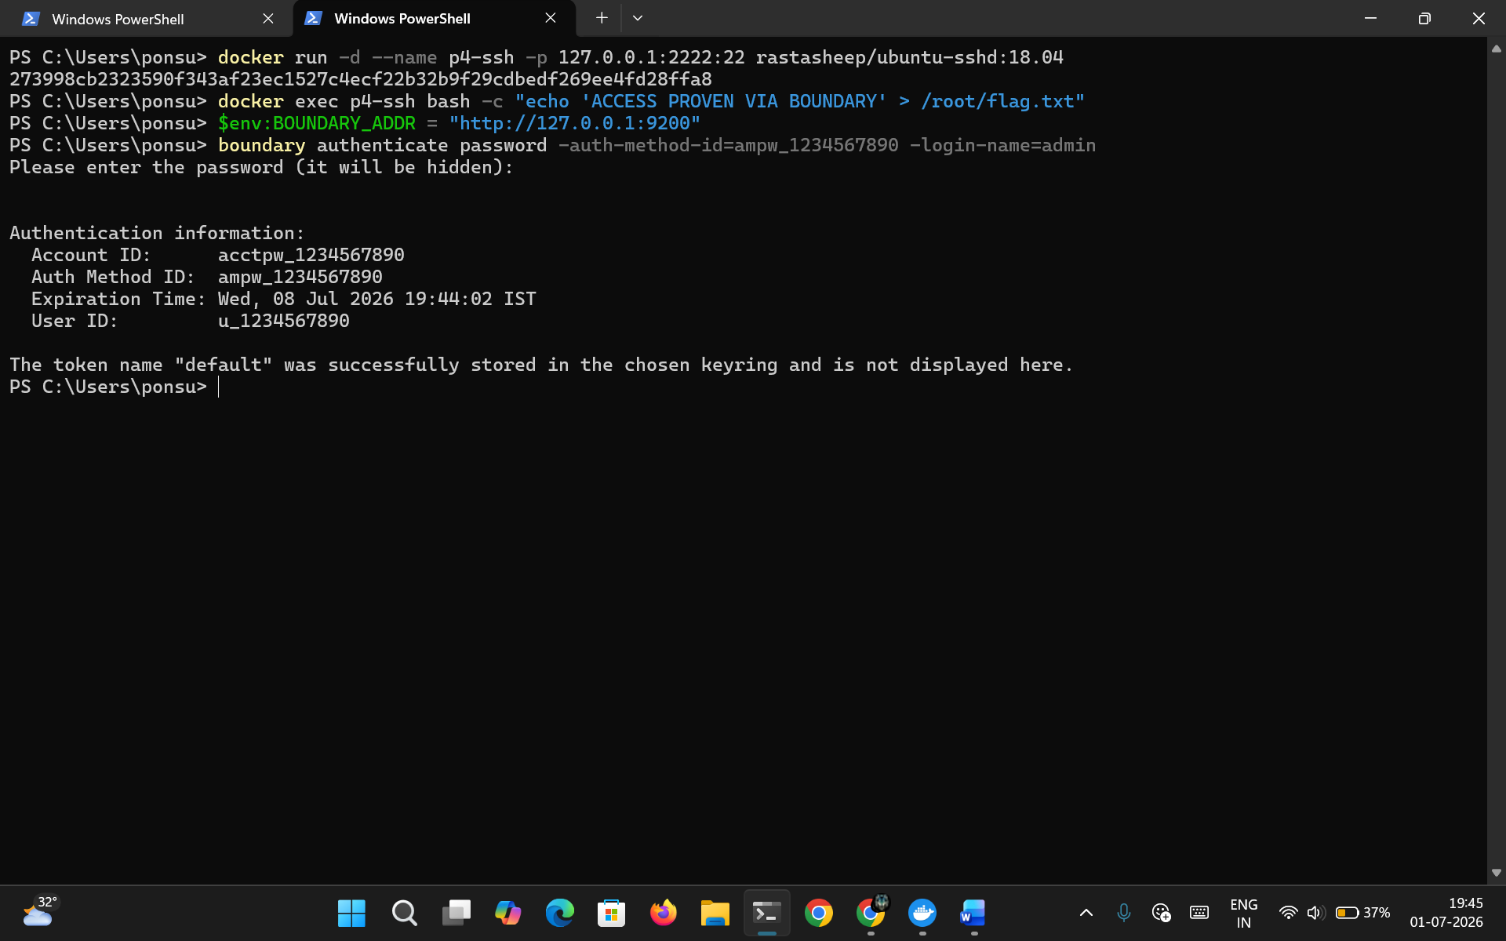
Figure 2.6: Boundary CLI Authentication and Project Scope Identification
This figure illustrates successful administrator authentication using the Boundary Command Line Interface. The output confirms successful login and displays the available project scope that will be utilized for configuring protected infrastructure resources.

Epic 3 – Secure Resource Configuration
This Epic covers the creation and configuration of infrastructure resources required for secure remote administration. HashiCorp Boundary organizes protected infrastructure using Host Catalogs, Static Hosts, Host Sets, and TCP Targets. These resources collectively define how authenticated administrators securely access protected servers without exposing SSH services directly to external networks.
Story 3.1: Creating the Host Catalog
A Host Catalog is a logical repository that stores and organizes infrastructure resources managed by HashiCorp Boundary. Every protected host registered within Boundary belongs to a Host Catalog, enabling centralized administration and simplified infrastructure management.
The Host Catalog is created inside the identified Project Scope using the Boundary CLI. Once created successfully, it serves as the parent resource for all Static Hosts and Host Sets configured throughout the implementation.
The Host Catalog provides a scalable method for organizing multiple infrastructure resources while maintaining centralized access management and resource isolation.

Host Catalog Creation Steps:
Step 1 – Authenticate to the Boundary CLI using the Password Authentication Method.
Step 2 – Identify the Project Scope ID.
Step 3 – Execute the Host Catalog creation command.
Step 4 – Verify the successful creation of the Host Catalog.
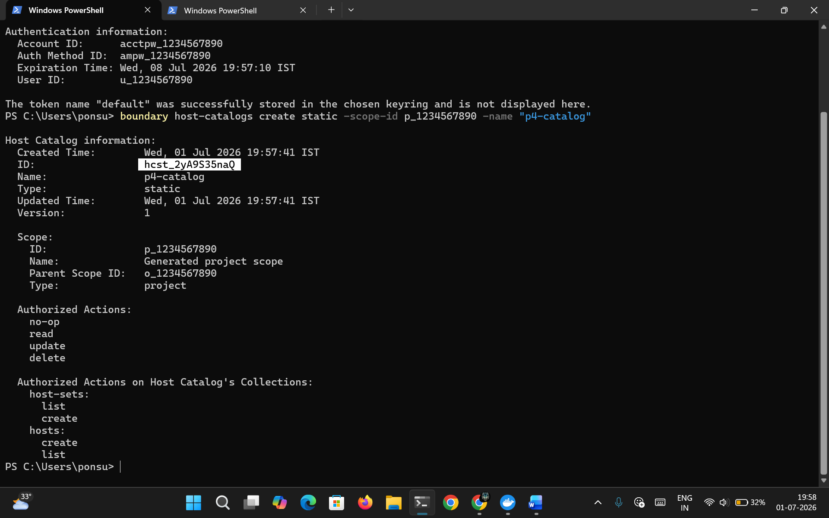
Figure 3.1: Creation of Static Host Catalog
This figure illustrates the successful creation of the Static Host Catalog within the configured Project Scope. The Host Catalog serves as the centralized repository for organizing protected infrastructure resources managed by HashiCorp Boundary.

Story 3.2: Creating the Static Host
After creating the Host Catalog, the protected Ubuntu SSH Server is registered within Boundary as a Static Host. A Static Host represents an infrastructure resource with a fixed network address that can be securely accessed through Boundary.
The Docker-based SSH Server is configured using the localhost address (127.0.0.1), allowing Boundary to identify the protected resource without exposing it to external networks.
Following successful registration, the Static Host becomes available for secure session establishment through authorized Boundary Targets.

Static Host Creation Steps:
Step 1 – Specify the previously created Host Catalog.
Step 2 – Provide the localhost address (127.0.0.1) of the protected SSH Server.
Step 3 – Execute the Static Host creation command.
Step 4 – Verify successful host registration.
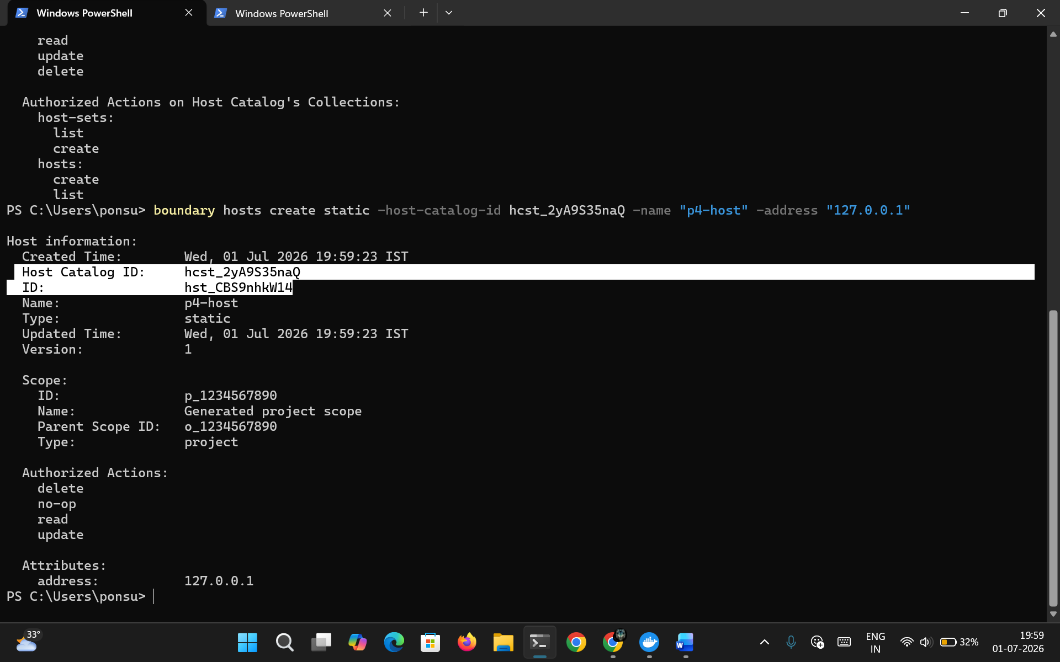
Figure 3.2: Registration of Static Host
This figure demonstrates the successful registration of the Docker-based Ubuntu SSH Server as a Static Host within the configured Host Catalog.

Story 3.3: Creating the Host Set
Host Sets provide a logical grouping mechanism for one or more registered hosts within a Host Catalog. Instead of assigning individual hosts directly to access targets, Boundary utilizes Host Sets to simplify infrastructure organization and resource management.
A Static Host Set is created inside the configured Host Catalog and subsequently associated with the registered Static Host. This relationship enables Boundary to identify which infrastructure resources belong to a particular secure access configuration.
The use of Host Sets improves scalability and simplifies future infrastructure expansion without requiring modifications to individual access targets.

Host Set Creation Steps:
Step 1 – Specify the Host Catalog.
Step 2 – Execute the Host Set creation command.
Step 3 – Verify successful Host Set creation.
Step 4 – Add the registered Static Host to the Host Set.
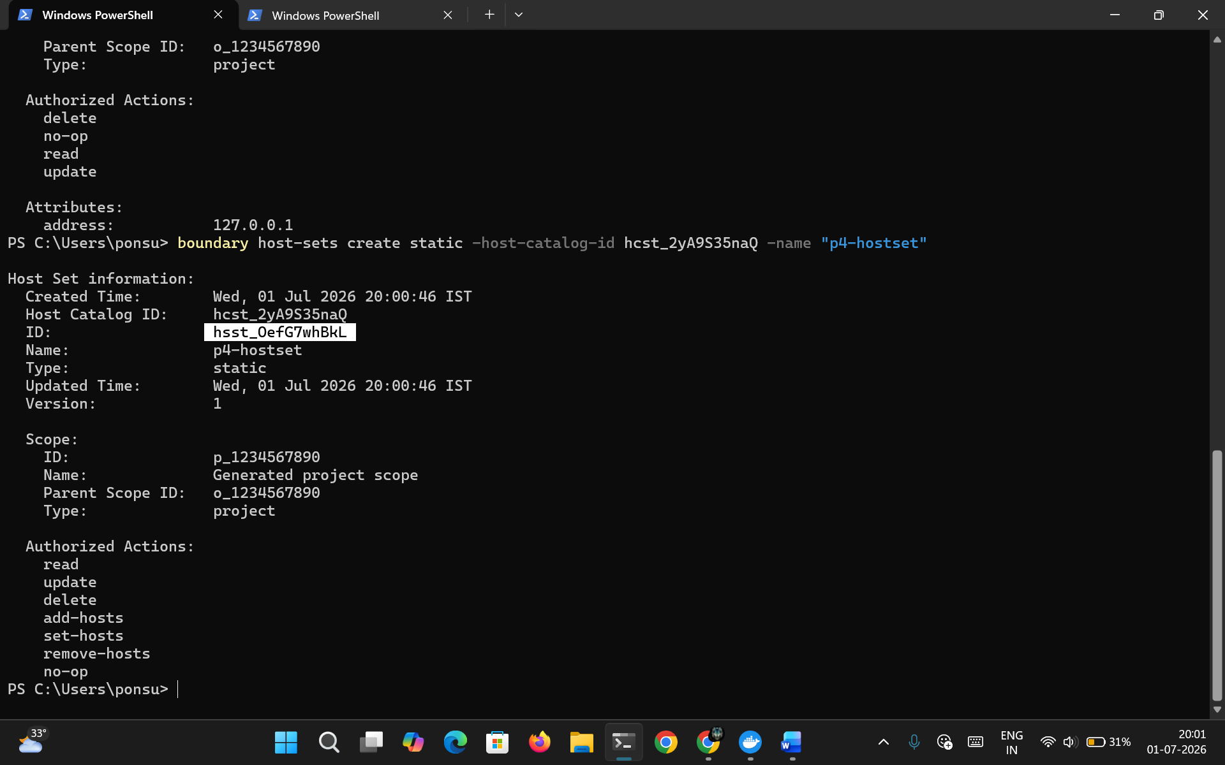
Figure 3.3: Creation of Static Host Set
This figure illustrates the successful creation of the Static Host Set used to logically organize protected infrastructure resources within the configured Host Catalog.
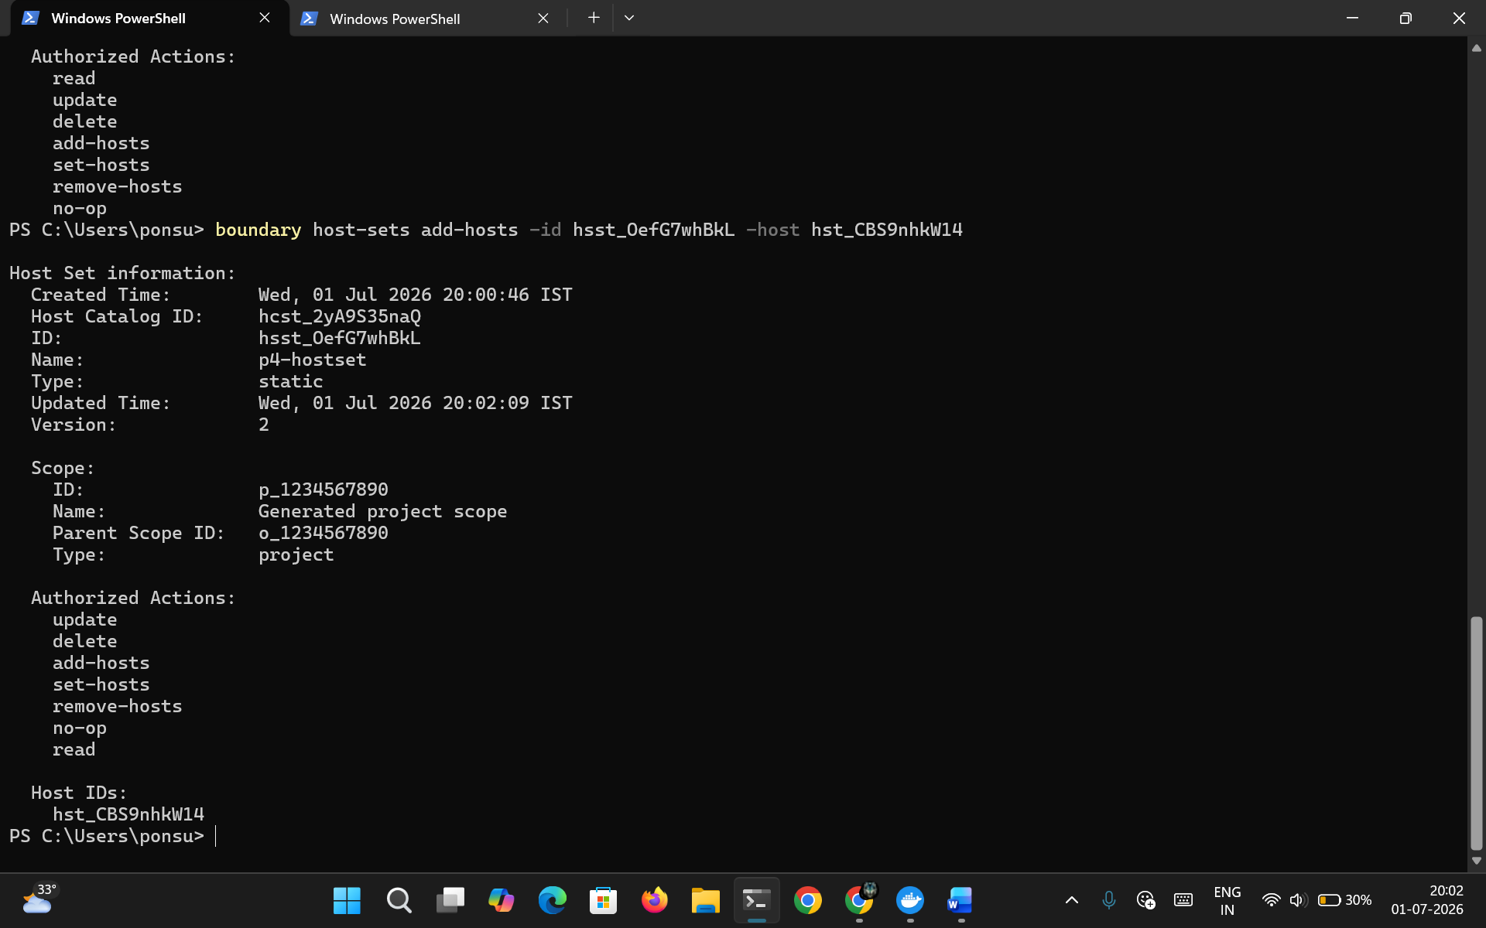
Figure 3.4: Association of Static Host with Host Set
This figure demonstrates the successful association of the registered Static Host with the configured Host Set, enabling Boundary to identify the protected infrastructure resource during session establishment.

Story 3.4: Creating the TCP Target
A TCP Target represents the secure connection endpoint through which authenticated administrators access protected infrastructure resources. Rather than exposing the SSH service directly, Boundary establishes secure sessions using configured Targets.
The TCP Target is configured to communicate with the Docker-based Ubuntu SSH Server over the SSH service port. After creating the Target, the configured Host Set is associated as the Target's Host Source, enabling Boundary to dynamically resolve the destination infrastructure whenever an authenticated connection request is received.
This implementation ensures that administrators never establish direct SSH connections to the protected server. Instead, every privileged session is securely brokered through HashiCorp Boundary following successful authentication and authorization.

TCP Target Configuration Steps:
Step 1 – Create a new TCP Target within the Project Scope.
Step 2 – Configure the Target to use the SSH communication port.
Step 3 – Associate the configured Host Set as the Target's Host Source.
Step 4 – Verify successful Target configuration.
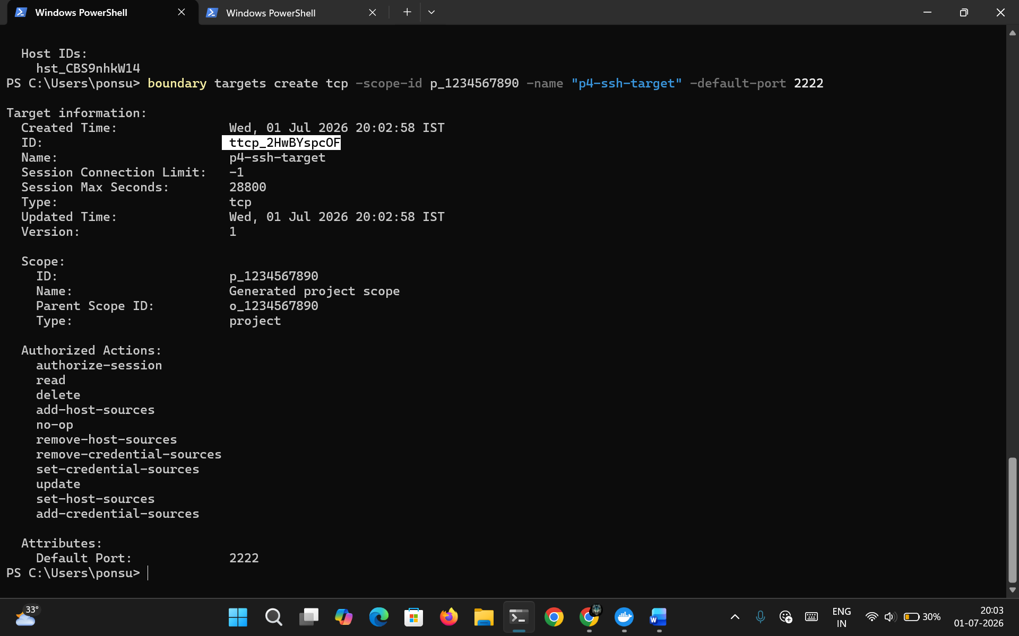
Figure 3.5: Creation of TCP Target
This figure illustrates the successful creation of the TCP Target responsible for securely brokering SSH communication between authenticated administrators and the protected Ubuntu SSH Server.
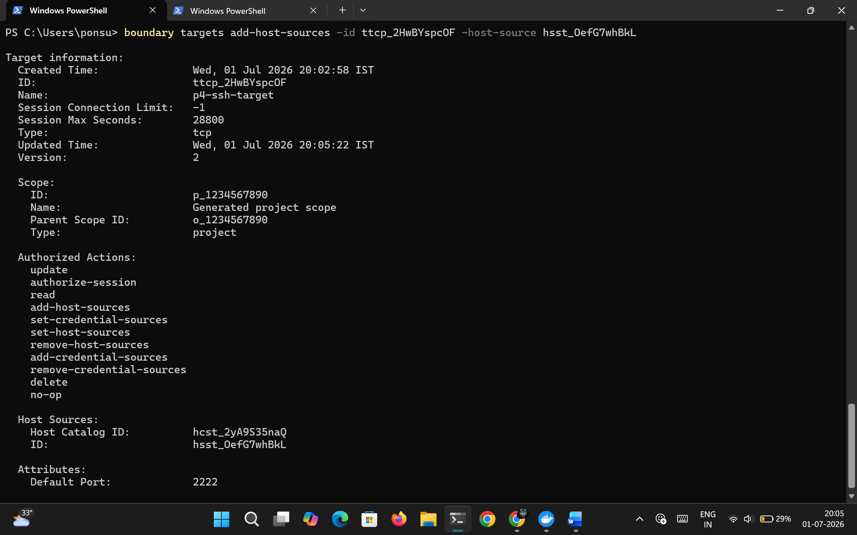
Figure 3.6: Association of Host Source with TCP Target
This figure demonstrates the successful association of the configured Host Set as the Host Source for the TCP Target. This enables HashiCorp Boundary to establish secure administrative sessions to the protected infrastructure.

Epic 4 – Secure Session Establishment and Validation
This Epic covers the establishment of a secure SSH session through HashiCorp Boundary and validates the implementation of Least Privilege Access by demonstrating successful retrieval of the protected resource while verifying that the SSH service remains inaccessible from external networks.
Story 4.1: Secure SSH Session Establishment
After successfully configuring the Host Catalog, Static Host, Host Set, and TCP Target, the administrator establishes a secure SSH session using the HashiCorp Boundary Command Line Interface.
Rather than exposing the SSH server directly, Boundary authenticates the administrator using the configured Password Authentication Method and validates the authorization policy associated with the requested Target. Once the administrator is successfully authenticated, Boundary creates a temporary encrypted session between the administrator and the protected Docker-based Ubuntu SSH Server.
The administrator is therefore granted privileged access only for the duration of the active session. Once the session terminates, the secure connection is automatically closed, ensuring that no permanent privileged access remains available.

Secure Session Establishment Steps
Step 1 – Authenticate to the Boundary CLI.
Step 2 – Specify the configured TCP Target ID.
Step 3 – Establish the secure SSH session.
Step 4 – Verify successful login to the protected Ubuntu SSH Server.
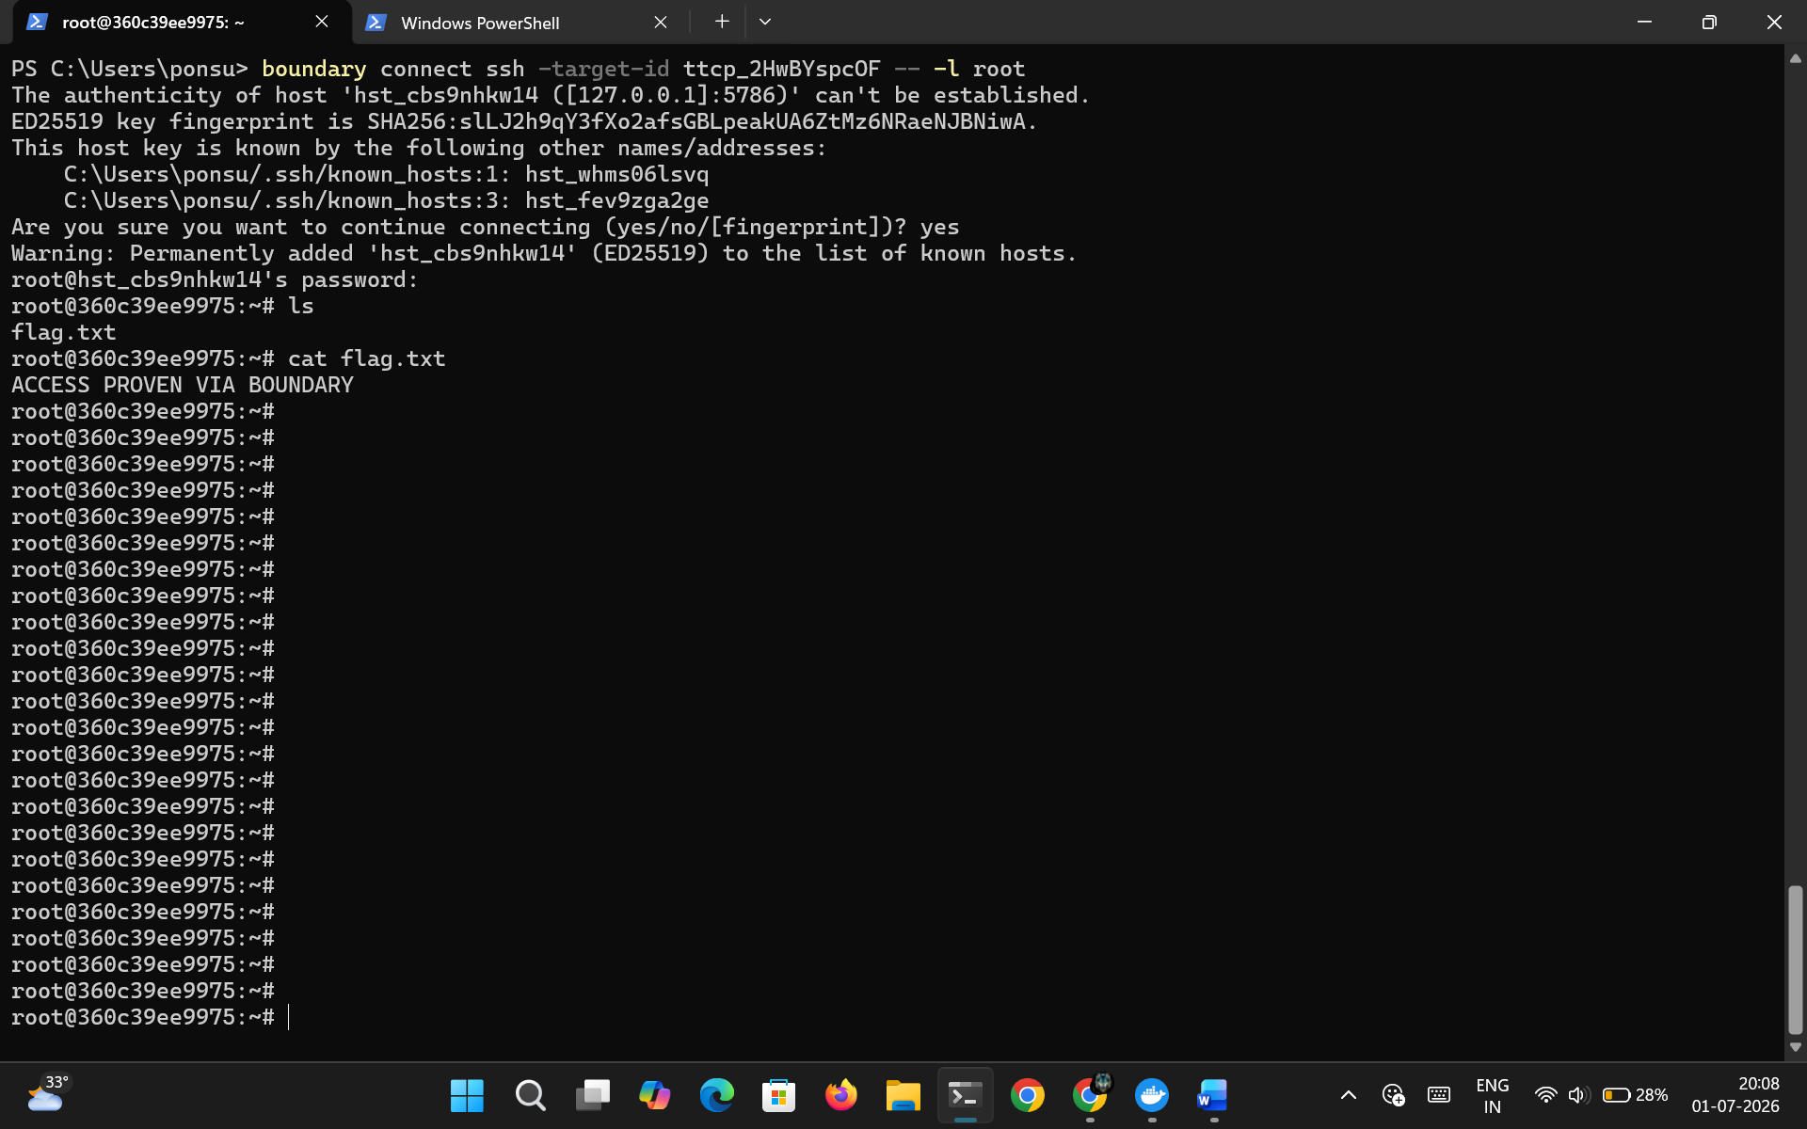
Figure 4.1: Secure SSH Session Established through HashiCorp Boundary
This figure illustrates the successful establishment of a secure SSH session through HashiCorp Boundary. The administrator authenticates using Boundary and securely accesses the protected Ubuntu SSH Server without exposing the SSH service directly to external networks.

Story 4.2: Retrieval of Protected Demonstration Resource
Following successful authentication and secure session establishment, the administrator accesses the protected Ubuntu environment and retrieves the demonstration resource (/root/flag.txt).
The demonstration file represents confidential infrastructure information that can only be accessed after successful identity verification and authorization through HashiCorp Boundary. Since the SSH service remains isolated from public networks, direct access to the resource is impossible without Boundary establishing the secure session.
Successful retrieval of the demonstration flag confirms that privileged administrative operations can be performed securely without exposing permanent SSH credentials or publicly accessible management services.

Demonstration Steps
Step 1 – Access the protected Ubuntu environment.
Step 2 – Navigate to the protected resource.
Step 3 – Retrieve the demonstration flag.
Step 4 – Verify successful access to the protected resource.

Figure 4.2: Retrieval of Protected Demonstration Flag
This figure demonstrates the successful retrieval of the protected demonstration file (/root/flag.txt) through the secure SSH session established by HashiCorp Boundary. The successful operation confirms the implementation of secure identity-based privileged access.

Story 4.3: Validation of Localhost-Bound SSH Service
The final stage of the implementation validates that the protected SSH service remains bound exclusively to the localhost interface (127.0.0.1:2222). This configuration ensures that the SSH server is inaccessible from external systems while remaining available for authorized Boundary sessions.
Network validation confirms that no public network interface exposes the SSH service. Instead, HashiCorp Boundary acts as the only authorized gateway to the protected infrastructure, significantly reducing the attack surface and eliminating the risks associated with publicly exposed administrative services.
This validation confirms that the implemented solution successfully enforces the Principle of Least Privilege while supporting secure administrative access through centralized identity verification.

Validation Steps
Step 1 – Verify the SSH service binding.
Step 2 – Confirm localhost-only accessibility.
Step 3 – Validate successful secure access through Boundary.
Step 4 – Confirm implementation of Least Privilege Access.
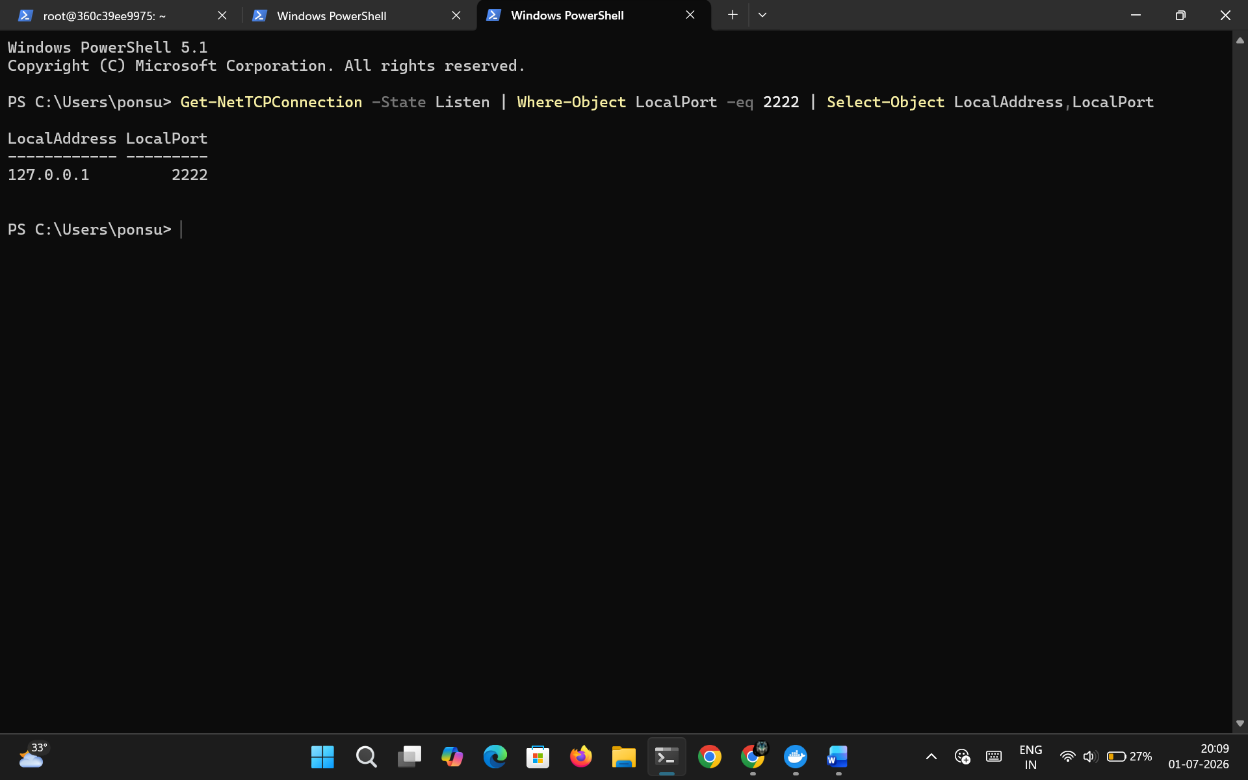
Figure 4.3: Verification of Localhost-Bound SSH Service
This figure illustrates the verification of the Docker-based SSH service listening exclusively on the localhost interface (127.0.0.1:2222). The output confirms that the protected infrastructure remains inaccessible from external networks while supporting secure access through HashiCorp Boundary.

Project Outcome
The implementation successfully demonstrates the use of HashiCorp Boundary as a centralized privileged access management solution for secure remote administration. By integrating Boundary with a Docker-based Ubuntu SSH Server, the project eliminates the need for publicly exposed SSH services and permanent administrative credentials.
Infrastructure resources were securely organized using Host Catalogs, Static Hosts, Host Sets, and TCP Targets, enabling administrators to establish authenticated and authorized SSH sessions only when required. The successful retrieval of the protected demonstration file and validation of the localhost-bound SSH service confirm the practical implementation of the Principle of Least Privilege within a Zero Trust environment.

Applications
The implementation of Least Privilege Access using HashiCorp Boundary provides a secure and scalable solution for privileged remote access across modern enterprise environments. The project demonstrates several practical applications in real-world cybersecurity infrastructure.
- Secure remote administration of Linux and Windows servers.
- Privileged access management (PAM) for enterprise infrastructure.
- Zero Trust implementation for administrative access.
- Secure access to cloud-hosted virtual machines.
- Identity-based access management for DevOps and Site Reliability Engineering (SRE) teams.
- Protection of internal infrastructure without exposing SSH services publicly.
- Temporary Just-in-Time (JIT) administrative access for contractors and third-party vendors.
- Secure management of production servers in hybrid and cloud environments.

Advantages
The implemented solution provides several security and operational advantages over traditional SSH-based administrative access.
- Eliminates publicly exposed SSH services.
- Removes dependency on permanent SSH keys.
- Implements the Principle of Least Privilege.
- Establishes temporary authenticated sessions.
- Centralizes privileged access management.
- Reduces the attack surface of protected infrastructure.
- Improves auditing and administrative accountability.
- Supports Zero Trust security architecture.
- Simplifies secure remote access without requiring traditional VPN connectivity.
- Enables scalable management of multiple protected resources.

Limitations
Although the implementation successfully demonstrates secure privileged access management, certain limitations exist due to the development environment.
- Boundary Developer Mode is intended only for development and demonstration purposes.
- The project uses an in-memory database; configuration is lost after restarting the Developer Server.
- Only a single Docker-based SSH server is demonstrated.
- Advanced enterprise authentication providers (LDAP, Active Directory, OIDC, SAML) are not integrated.
- Multi-worker deployments and high availability configurations are not implemented.
- Session recording and enterprise audit integrations are outside the scope of this implementation.
- Fine-grained role-based authorization policies are limited within the demonstration environment.

Future Enhancements
Several improvements can further extend the functionality and enterprise readiness of the implemented solution.
- Deploy HashiCorp Boundary in production mode with persistent storage.
- Integrate enterprise Identity Providers such as Microsoft Entra ID, Keycloak, LDAP, or Active Directory.
- Configure multi-worker Boundary architecture for high availability.
- Implement Multi-Factor Authentication (MFA) for privileged access.
- Integrate session recording and monitoring capabilities.
- Secure access to Kubernetes clusters, databases, and cloud-native services.
- Automate infrastructure provisioning using Terraform.
- Integrate Boundary with HashiCorp Vault for dynamic credential generation.
- Deploy the solution across multi-cloud and hybrid cloud environments.
- Enable centralized logging and security monitoring using SIEM platforms.

Learning Outcomes
During the implementation of this project, the following technical concepts and practical skills were acquired:
- Understanding the Principle of Least Privilege.
- Practical implementation of Zero Trust Architecture.
- Deployment and configuration of HashiCorp Boundary.
- Secure remote access using Boundary CLI.
- Docker container deployment and management.
- Configuration of Host Catalogs, Static Hosts, Host Sets, and TCP Targets.
- Secure SSH session establishment without exposing administrative services.
- Identity-based authorization for infrastructure resources.
- Verification of localhost-bound network services.
- Practical implementation of secure privileged access management.

Conclusion
The Least Privilege Access using HashiCorp Boundary project successfully demonstrates a modern identity-aware approach to privileged infrastructure management. Unlike traditional SSH administration models that rely on permanently exposed ports and long-lived credentials, the implemented solution authenticates administrators before establishing temporary secure sessions to protected infrastructure.
The deployment of HashiCorp Boundary in Developer Mode, together with a Docker-based Ubuntu SSH Server, effectively illustrates how centralized access management can improve infrastructure security while enforcing Zero Trust principles. The use of Host Catalogs, Static Hosts, Host Sets, and TCP Targets enables logical resource organization and secure session brokering without exposing administrative services directly to the network.
Successful retrieval of the protected demonstration file (/root/flag.txt) through HashiCorp Boundary and verification that the SSH service remains bound exclusively to the localhost interface validate the effectiveness of the implemented Least Privilege model. Overall, the project demonstrates a secure, scalable, and practical approach to privileged access management suitable for modern enterprise environments.

References
- HashiCorp Boundary Official Documentation.
- HashiCorp Boundary CLI Documentation.
- Docker Official Documentation.
- OpenSSH Documentation.
- National Institute of Standards and Technology (NIST) – Zero Trust Architecture (SP 800-207).
- Principle of Least Privilege Security Guidelines.
- Docker Hub – Ubuntu SSH Server Image (rastasheep/ubuntu-sshd:18.04).

Appendix
A.1 Boundary & Docker Commands Reference
Command | Description
boundary dev | Starts the HashiCorp Boundary Developer Server in Developer Mode.
docker run -d --name p4-ssh -p 127.0.0.1:2222:22 rastasheep/ubuntu-sshd:18.04 | Creates and starts the Ubuntu SSH Server container.
docker start p4-ssh | Starts the existing SSH container.
docker stop p4-ssh | Stops the SSH container.
docker restart p4-ssh | Restarts the SSH container.
docker ps | Displays running Docker containers.
docker ps -a | Displays all Docker containers.
docker exec -it p4-ssh bash | Opens an interactive shell inside the SSH container.
docker logs p4-ssh | Displays container logs.
boundary authenticate password | Authenticates to HashiCorp Boundary.
boundary scopes list | Lists available scopes.
boundary host-catalogs create static | Creates a Static Host Catalog.
boundary hosts create static | Creates a Static Host.
boundary host-sets create static | Creates a Static Host Set.
boundary host-sets add-hosts | Associates the Static Host with the Host Set.
boundary targets create tcp | Creates a TCP Target.
boundary targets add-host-sources | Associates the Host Set with the TCP Target.
boundary connect ssh | Establishes a secure SSH session.

A.2 Boundary Configuration Components
Component | Purpose
HashiCorp Boundary | Centralized Privileged Access Management platform.
Boundary Controller | Authentication, authorization and session management.
Boundary Worker | Securely brokers client connections.
Docker Container | Hosts the Ubuntu SSH Server.
Ubuntu SSH Server | Protected infrastructure resource.
Host Catalog | Organizes managed infrastructure resources.
Static Host | Represents the protected SSH Server.
Host Set | Groups protected hosts.
TCP Target | Defines the secure SSH endpoint.
Boundary CLI | Administration and secure session establishment.
Protected Resource | /root/flag.txt used for validation.

A.3 Troubleshooting Guide
Symptom | Likely Cause | Resolution
Unable to authenticate to Boundary CLI | Incorrect Authentication Method ID or credentials | Verify the Authentication Method ID, username and password.
Unable to create Host Catalog | Duplicate Host Catalog name | Use a unique name or delete the existing Host Catalog.
Static Host creation fails | Incorrect Host Catalog ID | Verify the Host Catalog ID.
SSH session cannot be established | Docker container is not running | Start the container using docker start p4-ssh.
/root/flag.txt cannot be accessed | Flag file not created | Create /root/flag.txt inside the container.
TCP Target connection fails | Host Set not associated | Associate the Host Set with the configured TCP Target.
SSH service inaccessible | Incorrect port mapping | Verify mapping to 127.0.0.1:2222.

A.4 Project Configuration Summary
Configuration | Value
Project Name | Least Privilege Access using HashiCorp Boundary
Access Management Platform | HashiCorp Boundary
Deployment Mode | Boundary Developer Mode
Container Platform | Docker Desktop
Protected Resource | Ubuntu SSH Server
Authentication Method | Password Authentication
Host Catalog | p4-catalog
Static Host | p4-host
Host Set | p4-hostset
TCP Target | p4-target
Protected File | /root/flag.txt
SSH Port Mapping | 127.0.0.1:2222 → 22
Administration Interface | Boundary CLI
Security Model | Least Privilege Access & Zero Trust Architecture

